AP Chemistry Unit 4: Chemical Equilibrium
Guided Notes
Name: ______________________ Date: ______________ Period: ______

Learning goals
- Explain equilibrium as a dynamic state and interpret graphs of rate and concentration.
- Write K_{c} and K_{p} expressions and explain what the size of K means.
- Use ICE tables (with concentrations or partial pressures) to find K or equilibrium amounts.
- Change K when a reaction is reversed, scaled, or added to other reactions.
- Use Q to decide which way a reaction will shift.
- Use Le Châtelier's principle to predict the effect of stresses.
Fill in each blank as we go. Show your work in the boxes.

1. What Is Equilibrium?
A reaction is reversible when the products can react to re-form the reactants. We show this with a double arrow, ⇌.
Define chemical equilibrium in terms of the forward and reverse reactions:

What happens to the concentrations (or pressures) at equilibrium? Are they necessarily equal?

Why is equilibrium called "dynamic"?

Example: A + B ⇌ C + D
Once equilibrium is established, describe (1) the rates of the forward and reverse reactions and (2) the concentrations of A, B, C, and D:

Start with only A and B. On the axes, sketch the forward rate and the reverse rate over time, and mark when equilibrium is reached.
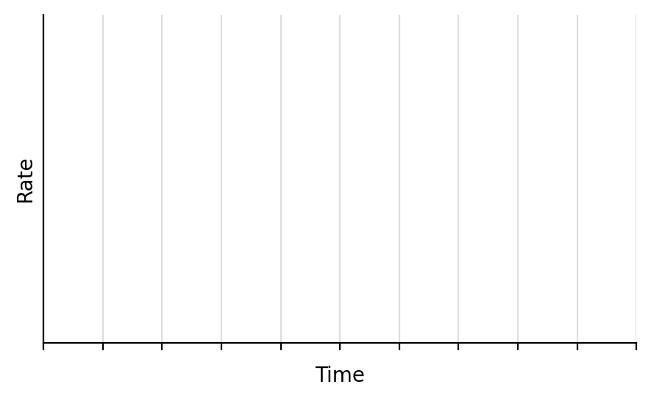

Common misconceptions
List three things that equilibrium does NOT mean or require:

Example: 2NO₂(g) ⇌ N₂O₄(g)
The initial pressure of NO₂ is 3.0 atm and no N₂O₄ is present. At equilibrium the pressure of NO₂ is 1.0 atm. Graph pressure vs. time for both gases. Label the axes with intervals (a scale for the vertical axis).
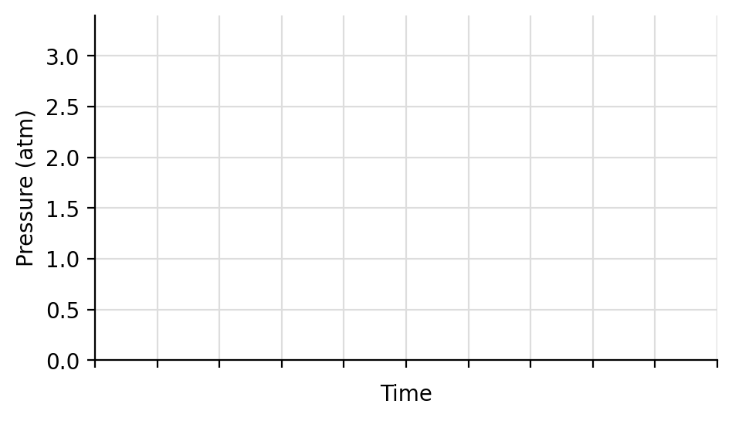
a) Pressure of N₂O₄ at equilibrium: (NO₂ fell by 2.0 atm, and every 2 NO₂ make 1 N₂O₄).
b) Total pressure at equilibrium:
c) K_{p} =

2. The Law of Chemical Equilibrium
For the reaction aA + bB ⇌ cC + dD:
Write the general expressions for K_{c} and K_{p}:

Rules for writing K
List the rules for writing K (top vs. bottom, exponents, what is left out, K_{c} vs. K_{p}, units, and what changes K):

What does the size of K mean?
Range of K | Meaning at equilibrium
K ≪ 1
K ≫ 1
K = 1
K > 1.0 × 10⁷

What does K tell us about a reaction, and what does it NOT tell us?

Example: Write the equilibrium expression for CaCO₃(s) ⇌ CaO(s) + CO₂(g)
Wrong: K_{c} =
Correct: K_{c} = K_{p} = (Solids are left out.)
Example: Write K_{c} and K_{p} for 2NH₃(g) ⇌ N₂(g) + 3H₂(g)

3. Solving for K and Concentrations Using an ICE Table
I = Initial, C = Change, E = Equilibrium.
List the steps for solving an ICE table problem:

Example: COCl₂(g) ⇌ CO(g) + Cl₂(g)
3.0 mol of COCl₂ are added to a 1.5 L container at 650 K. At equilibrium [COCl₂] = 0.25 M. Calculate K_{c} and describe the equilibrium as reactant favored, product favored, or neither.
 | [COCl₂] | [CO] | [Cl₂]
I
C
E

Example: 2NH₃(g) ⇌ N₂(g) + 3H₂(g)
3.0 mol of NH₃ are placed in a 1.5 L container. At equilibrium [NH₃] = 0.5 M. Calculate K_{c} and describe the equilibrium as reactant favored, product favored, or neither.
 | [NH₃] | [N₂] | [H₂]
I
C
E

4. Equilibrium with Partial Pressures (Dalton's Law)
State Dalton's law of partial pressures:

Why can we use pressures in an ICE table instead of concentrations?

If the total pressure at equilibrium is given, how do we find x?

Example: 2H₂(g) + O₂(g) ⇌ 2H₂O(g)
Initial pressures: P_{H₂} = 1.3 atm and P_{O₂} = 1.1 atm. The total pressure at equilibrium is 2.3 atm. Calculate K_{p}.
 | P_{H₂} | P_{O₂} | P_{H₂O}
I
C
E

Example: PCl₅(g) ⇌ PCl₃(g) + Cl₂(g)
The initial pressure of PCl₅ is 1.66 atm. At equilibrium the total pressure is 2.35 atm. Calculate K_{p}.
 | P_{PCl₅} | P_{PCl₃} | P_{Cl₂}
I
C
E

Example: Br₂(g) + I₂(g) ⇌ 2IBr(g), K_{p} = 70
0.25 atm of Br₂ is combined with 0.25 atm of I₂. What is P_{IBr} at equilibrium? What is the total pressure?
 | P_{Br₂} | P_{I₂} | P_{IBr}
I
C
E

5. When Can We Ignore −x? (Small K Approximation)
When can we use the small-x approximation? Describe the conditions and what it lets us do:

Example: H₂CO₃(aq) ⇌ H⁺(aq) + HCO₃⁻(aq), K_{c} = 4.3 × 10⁻⁷
Determine [HCO₃⁻] if the initial [H₂CO₃] = 1.20 M.
 | [H₂CO₃] | [H⁺] | [HCO₃⁻]
I
C
E

Example: N₂(g) + O₂(g) ⇌ 2NO(g), K_{c} = 4.2 × 10⁻⁸
The initial [N₂] = 0.085 M and [O₂] = 0.038 M. What is [NO] at equilibrium?
 | [N₂] | [O₂] | [NO]
I
C
E

6. Manipulating Reactions and the Effect on K
If you… | Then K…
Multiply all coefficients by n
Reverse the reaction
Add two or more reactions together

Example: 2A + B ⇌ 3C, K_{c} = 2.5 × 10⁻³
How does each change affect K_{c}?
a) 4A + 2B ⇌ 6C K_{c} = (coefficients ×2)
b) A + ½B ⇌ (3/2)C K_{c} = (coefficients ×½)
c) 3C ⇌ 2A + B K_{c} = (reversed)
Example: Calculate K_{c} for 2N₂O + 3O₂ ⇌ 2N₂O₄
Rxn 1: 2N₂ + O₂ ⇌ 2N₂O K_{c} = 1.2 × 10⁻³⁵
Rxn 2: N₂O₄ ⇌ 2NO₂ K_{c} = 4.6 × 10⁻³
Rxn 3: ½N₂ + O₂ ⇌ NO₂ K_{c} = 4.1 × 10⁻⁹
Goal: manipulate the given reactions so they add up to the overall reaction. Manipulate K in the same way.

7. The Reaction Quotient (Q)
Define the reaction quotient, Q:

How is Q different from K?

Comparison | Meaning | Shift
Q < K
Q = K
Q > K

Steps: (1) write Q, (2) substitute the current values (change moles to M if needed), (3) compare Q to K, (4) decide the shift.
Example: N₂(g) + 3H₂(g) ⇌ 2NH₃(g), K_{p} = 1.64 × 10⁻⁴
A closed vessel contains 1.5 atm N₂, 3.2 atm H₂, and 0.75 atm NH₃.
a) How do we check if the reaction is at equilibrium?

b) Is the reaction at equilibrium? If not, which way does it shift?

Example: SO₂Cl₂(g) ⇌ SO₂(g) + Cl₂(g), K_{c} = 0.078 at 100 °C
0.035 mol SO₂, 0.500 mol SO₂Cl₂, and 0.080 mol Cl₂ are combined in a sealed 5.00 L flask at 100 °C. Is the reaction at equilibrium? If not, which way does it shift?

Example: At 445 °C, K_{c} = 0.020 for 2HI(g) ⇌ H₂(g) + I₂(g)
[HI] = 2.0 M, [H₂] = 0.50 M, [I₂] = 0.10 M. Which statement is TRUE?
(a) Q_{c} = K_{c}; the system is at equilibrium.
(b) Q_{c} is less than K_{c}; more H₂ and I₂ will be produced.
(c) Q_{c} is less than K_{c}; more HI will be produced.
(d) Q_{c} is greater than K_{c}; more H₂ and I₂ will be produced.
(e) Q_{c} is greater than K_{c}; more HI will be produced.

8. Le Châtelier's Principle
State Le Châtelier's principle:

What does a shift right or left mean? Does a shift fully cancel the stress?

There are 4 types of stress: concentration, temperature, volume of gases, and volume of solutions.

Stress 1: Concentration (or Partial Pressure)
Stress | Q compared with K | Shift
Add a reactant
Remove a reactant
Add a product
Remove a product

What happens if a solid or pure liquid is added or removed?

Example: N₂(g) + 3H₂(g) ⇌ 2NH₃(g)
Fill in the effect on each species as the system shifts. Use ↑ (increases), ↓ (decreases). The arrows describe what happens after the stress, as the system shifts.
Stress | Shift | [N₂] | [H₂] | [NH₃]
Add N₂
Add H₂
Add NH₃
Remove NH₃

(The added or removed substance itself moves back part of the way toward its original value as the system shifts.)
Example: N₂O₄(g) ⇌ 2NO₂(g)
a) Write K_{c}:

b) The system is at equilibrium. At the dashed line, extra NO₂ is added. Sketch how both concentrations change until a new equilibrium is reached.
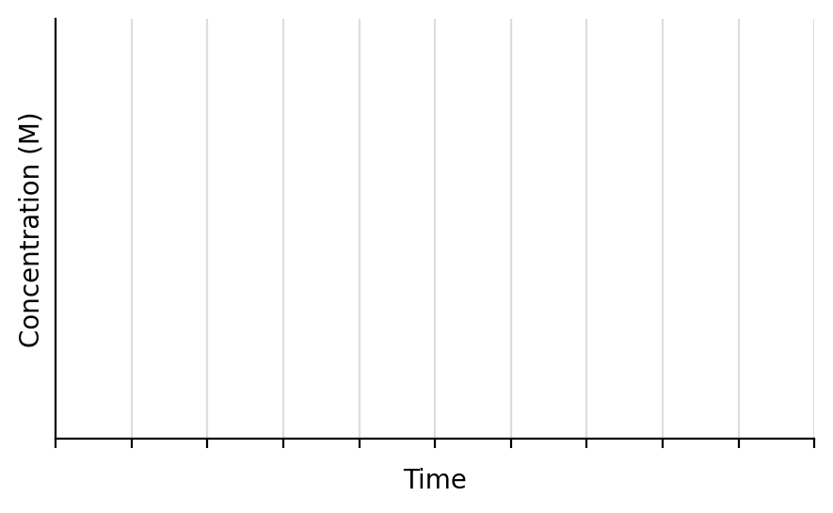
c) Use Q to explain:

d) On the graph below, show what happens if extra N₂O₄ is added instead. Use Q to explain.
Use Q to explain:

Stress 2: Temperature
What is affected by temperature?

To predict the shift, write heat into the equation:
Reaction type | ΔH | Heat is a… | Increase T | Decrease T | K when T increases
Exothermic
Endothermic

Example: Exothermic: A + B ⇌ C + heat, K_{c} = 200 at 25 °C
The temperature is increased to 30 °C. Shift: K:
The temperature is lowered to 20 °C. Shift: K:
Example: Endothermic: heat + A + B ⇌ C, K_{c} = 200 at 25 °C
The temperature is increased to 30 °C. Shift: K:
The temperature is lowered to 20 °C. Shift: K:
Example: N₂(g) + 3H₂(g) ⇌ 2NH₃(g), ΔH = −92 kJ/mol
a) Where is the heat in the reaction?

b) The temperature is lowered. Which way does it shift? Use K and Q to explain.

Stress 3: Volume of Gases (change in container size)
Example: N₂(g) + 3H₂(g) ⇌ 2NH₃(g)
The reaction is at equilibrium in a 3.0 L container. The gases are moved into a 1.5 L container. Use Q to explain the effect on equilibrium.

Fast way to determine the shift:
Fast way to determine the shift for volume changes of gases:

Stress 4: Volume of Solutions (adding solvent)
Example: HC₂H₃O₂(aq) ⇌ H⁺(aq) + C₂H₃O₂⁻(aq), K_{c} = 1.8 × 10⁻⁵
a) Write K_{c}:

b) 2.0 L of H₂O is added to 1.0 L of 1.0 M acetic acid. Do the moles of C₂H₃O₂⁻ increase, decrease, or stay the same? Use Q to explain.

Fast way to determine the shift when solvent is added or removed:

Non-stressors: things that do NOT shift equilibrium
Catalyst: what does it do to equilibrium?

Surface area of a solid reactant: what does it do to equilibrium?

Adding a non-reactive gas (constant volume): what does it do to equilibrium?

9. Summary
Stress | Shift | Does K change?
Add reactant / remove product
Add product / remove reactant
Increase T (endothermic)
Increase T (exothermic)
Decrease volume (gases)
Increase volume (gases)
Add solvent (dilute)
Catalyst, solid surface area, inert gas

Exit Ticket
1) Write K_{c} for 2SO₂(g) + O₂(g) ⇌ 2SO₃(g).

2) If K_{c} = 4.0 for the reaction in question 1, what is K_{c} for 2SO₃(g) ⇌ 2SO₂(g) + O₂(g)?

3) For N₂O₄(g) ⇌ 2NO₂(g), K_{c} = 0.36. A mixture has [N₂O₄] = 0.020 M and [NO₂] = 0.100 M. Which way does it shift?

4) An exothermic reaction at equilibrium is heated. Which way does it shift, and what happens to K?

5) For 2A(g) ⇌ B(g), what happens if the volume of the container is decreased?

6) Which stress changes the value of K?

